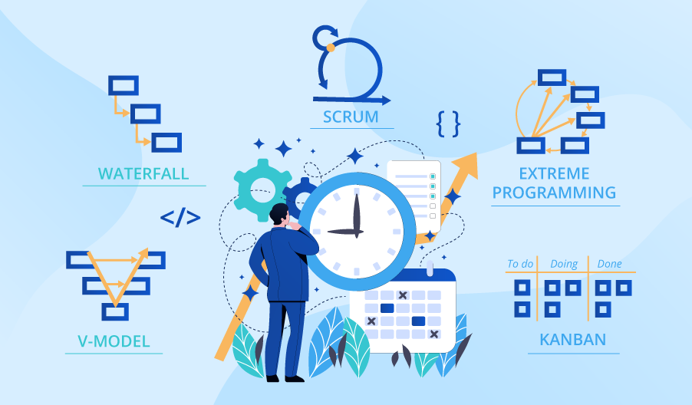

**SE423**

**Software Project Management**

**Activity**

**Activity 3. Myers-Briggs Personality Activity**

Complete the following individual and group activities.

**Individual**

As an individual, complete the following questions:

1. Complete the [Myers-Briggs Personality Test](http://www.humanmetrics.com/cgi-win/JTypes2.asp)
2. Record the results by creating a screenshot or copying and pasting into a document
3. Upload your individual results into LMS
4. Review the Facilitating Communication article, available in the course website

**Group**

Meet with your group and, as a group, answer the following questions in order:

1. What would the makeup (in terms of Myers-Briggs) of the ideal Software Engineering team consist of?
2. Compare your indicator numbers. Are they what you expected? Any surprises?
3. Look at the Classic Mistakes. Which ones might your team or team members be prone to?
4. If someone in your team has different numbers, how can they help avoid those mistakes? If not, which personality type might you seek to add to your team? Which mistakes may they be prone to?

Be sure to include all group member's names in your submission.